COMPARE PRODUCTS MOBILE QA REPORT
Live URL | https://dev-daam-dekho-web.onrender.com/compare-products
Primary Viewport | 390 × 844 (Mobile Primary)
Additional Viewports | 375 × 812, 412 × 915
Test Date | August 17, 2026
Overall Status | PASS WITH ISSUES (🟡 17 Passed, 2 Failed)

📹 1. Screen Recording & Session Capture
The complete focused QA testing session for the Compare Products page was recorded in high definition during automated browser testing.

📷 2. Visual Evidence & Screenshots

Initial Page Load & Compare Matrix (390×844)
Page loads cleanly without body-level horizontal overflow. 4 products loaded. Header, category tabs, and bottom sticky bar are all visible.
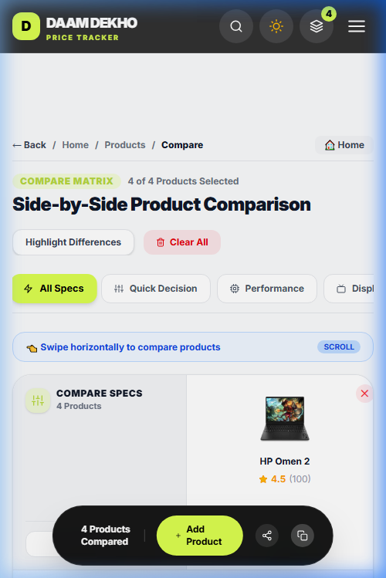
Figure: Initial Page Load & Compare Matrix (390×844)

Category Tab Navigation (Performance Tab Active)
Category tabs container supports horizontal scrolling. Selecting a tab highlights it in green and filters the specs table cleanly.
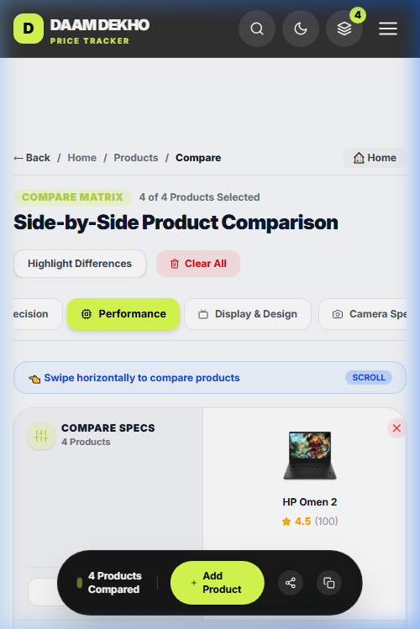
Figure: Category Tab Navigation (Performance Tab Active)

Horizontal Product Swiping & Fixed Spec Label Column
Left-most specification label column stays fixed on the left while product columns scroll horizontally underneath it. Row alignments remain exact.
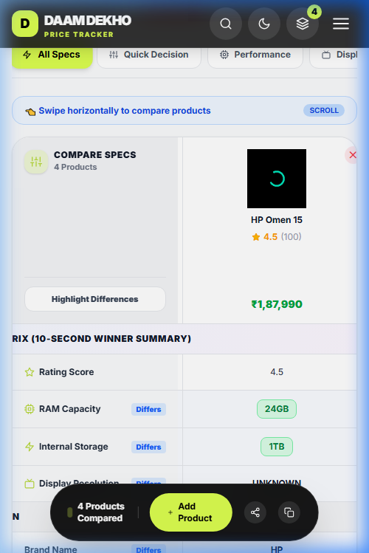
Figure: Horizontal Product Swiping & Fixed Spec Label Column

Hamburger Menu Overlay Defect (Invisible Overlay)
Tapping the hamburger menu toggles icon to 'X', but navigation menu overlay rendered in DOM remains visually transparent/invisible on screen.
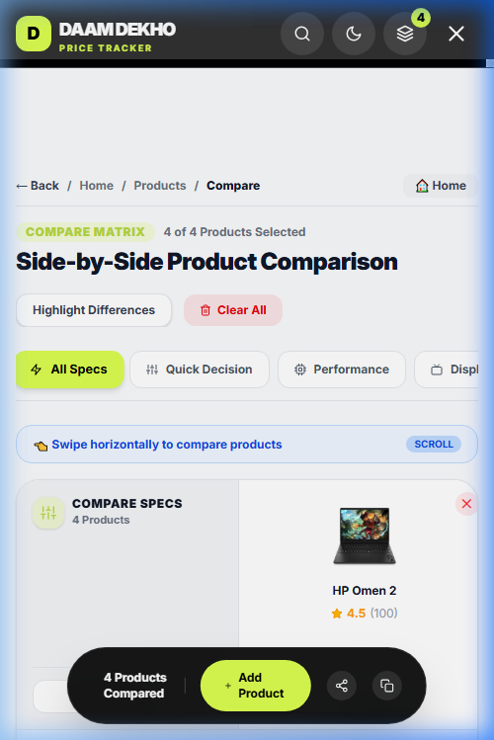
Figure: Hamburger Menu Overlay Defect (Invisible Overlay)

Dark/Light Theme Toggle Defect
Tapping the theme button toggles the header icon, but main page body background remains light mode.
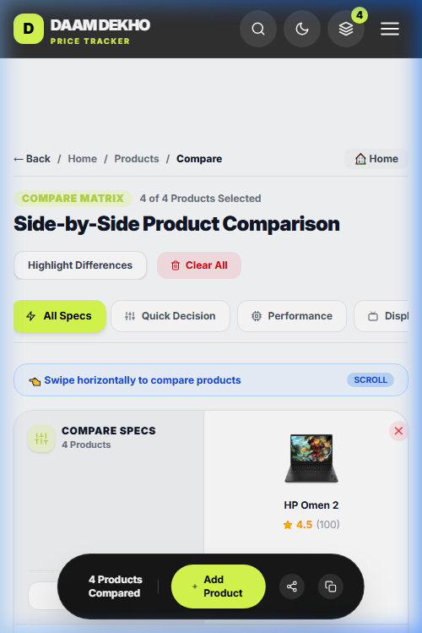
Figure: Dark/Light Theme Toggle Defect

📊 3. Test Summary Matrix
Test Area | Status | Observations & Issues
Page Load | PASS | Page loads successfully without horizontal body overflow.
Header | FAIL | Hamburger menu overlay is transparent/invisible when active. Theme toggle does not switch body theme color.
Tabs | PASS | Category tabs scroll horizontally and switch active states cleanly.
Horizontal Product Scroll | PASS | Product columns swipe smoothly horizontally.
Product Images | PASS | Images load properly without cropping or distortion.
Product Names | PASS | Product titles wrap correctly within column bounds.
Ratings | PASS | Rating numbers and stars display clearly.
Prices | PASS | Currency symbol and price values remain aligned.
Specification Rows | PASS | Spec row heights match and 'Differs' badges render properly.
Fixed Specification Column | PASS | Left column stays fixed while products scroll horizontally.
Quick Decision Matrix | PASS | 'Quick Decision' tab correctly isolates summary rows.
Highlight Differences | PASS | Toggles diff rows correctly ('✓ Showing Diff').
Bottom Sticky Bar | PASS | Stays fixed at bottom; shows product count and actions.
Add Product | PASS | Navigates to product selection page. Rejects 5th product, but lacks toast alert.
Share | PASS | Share button fires share handler cleanly.
Copy/Duplicate | PASS | Copy link button copies comparison URL.
Vertical Scroll | PASS | Vertical scrolling is smooth; sticky bar remains pinned.
Combined Scroll | PASS | Simultaneous vertical scroll + horizontal swipe operates without conflict.
Responsive Layout | PASS | Tested across 375×812, 390×844, and 412×915 viewports with clean scaling.

🐛 4. Detailed Bugs Report

Bug #1: Mobile Hamburger Navigation Menu Content Invisible When Active
Severity | 🟠 High
Viewport | 375×812, 390×844, 412×915
Location | Top Navigation Header (button.p-2 / Navigation Drawer)
Steps to Reproduce | 1. Open https://dev-daam-dekho-web.onrender.com/compare-products on mobile viewport.  2. Tap the Hamburger menu button in the top right header.
Expected Result | Mobile navigation drawer/menu overlay should open visibly with navigation links.
Actual Result | The hamburger icon changes to an 'X' icon, and a fixed container is added to the DOM, but the menu background/links are invisible/transparent.


Bug #2: 'Clear All' Button Does Not Re-render Page to Empty State
Severity | 🟡 Medium
Viewport | 390×844
Location | Bottom Sticky Bar ('Clear All' button)
Steps to Reproduce | 1. Have 2 or more products loaded in the comparison table.  2. Click 'Clear All' in the bottom comparison bar.
Expected Result | Comparison matrix instantly unmounts, and page updates to display 'No Products Selected for Comparison' empty state.
Actual Result | State is cleared in React Context ([CompareContext] Cleared all comparisons), but table UI does not reactively unmount until a manual page refresh.

Bug #3: Missing Toast Alert When Reaching 4-Product Comparison Limit
Severity | 🟡 Medium
Viewport | 390×844
Location | Product Listing / Compare Button
Steps to Reproduce | 1. Add 4 products to comparison list.  2. Attempt to click 'Compare' on a 5th product.
Expected Result | A user-facing alert/toast notification should inform the user: 'Maximum 4 products can be compared at a time.'
Actual Result | The click is silently ignored in UI. Console logs [CompareButton] List full (4), cannot add 527, but no feedback is shown to user.

Bug #4: Dark/Light Theme Toggle Does Not Change Page Body Theme
Severity | 🔵 UI/UX Improvement
Viewport | 390×844
Location | Header Theme Button
Steps to Reproduce | 1. Tap the Theme toggle button in header.
Expected Result | Page background and component colors switch to dark mode aesthetics.
Actual Result | Theme button icon toggles between Sun and Moon, but main background colors remain light mode.


📈 5. Final Summary Metrics & Overall Status
• Total Test Cases Executed: 19
• Passed: 17
• Failed: 2 (Hamburger menu & Clear All state sync)
• Blocked: 0
• Total Bugs Discovered: 4
- Critical: 0
- High: 1
- Medium: 2
- Low / UI/UX: 1
OVERALL TEST STATUS: PASS WITH ISSUES (🟡)

